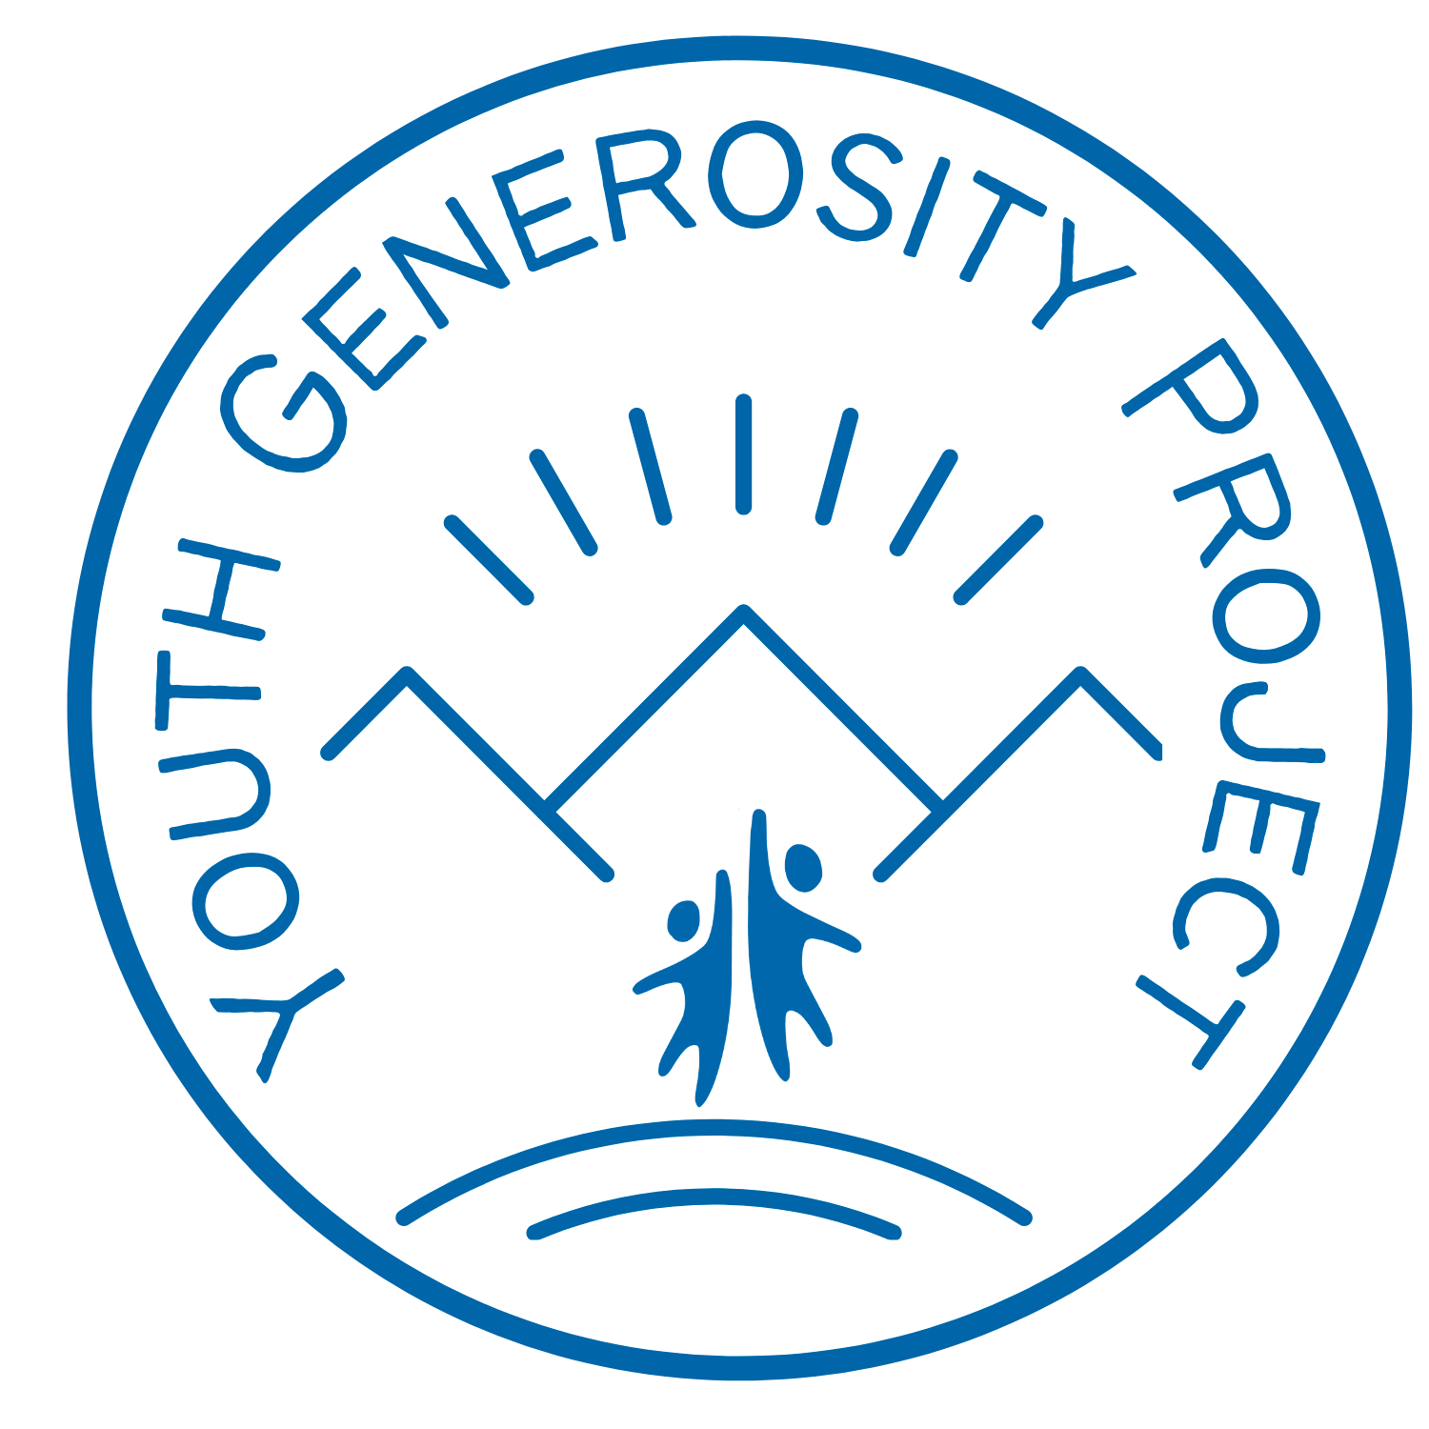

2021-2022 YOUTH PHILANTHROPY INITIATIVE
GRANT APPLICATION

Youth Generosity Project’s Youth Philanthropy Initiative (YPI) is accepting applications for grants of $500 to $5,000. Blaine County nonprofits who wish to be considered must complete the application detailed below. Under the guidance of Youth Generosity Project and a teacher, students at each local high school will vet grant applications, meet with finalists, and determine who receives grant reward(s).

All applications are due on Monday, November 15th by 5pm. We ask that you join us on Wednesday, December 1st at 5:30pm to meet our youth philanthropists and give a brief introduction to your organization and its grant proposal. You will be notified by late February whether or not your application has been selected for the finalist round. All finalists will be asked to meet with YPI students to further discuss their proposal if clarification is needed. Grant recipients will be notified by mid March 2022.

Please submit grant applications to: hollyn@hollyn.com

Guidelines
- Amount of request may not exceed $5,000
- Each proposal must be represented by a local (Blaine County) 501(c)3
- Application and project budget must be submitted via email to eherrick@wow-students.org by 5pm on Monday, November 15th, 2021
- Applicants will be asked to attend an evening event at the Community Campus and give a brief 2 minute outline of their nonprofit’s mission and proposal request to YPI students on Wednesday December 1, 2021 (organizations that cannot attend the evening presentation must submit a short video that includes a project description)

APPLICATION

Name of Organization:

Title of Grant Request:

Amount of Request:

Project Start and End Dates:

Contact Person:

Contact Phone:

Contact Email:

Organization’s Mission Statement:

- Project Summary: Up to 250 words.

- Community Need & Enrichment:
Please include:
- Your organization’s mission
- Brief project description
- The impact of your project (both short and long term) on our community
- Ask amount-- please clarify if your financial request will cover the entire project or not. If not, explain how you will fulfill the additional funding needs.

- Budget: Please include an itemized project budget:

Item: | Cost:
Staff (salaries):
Volunteer support (hours - if applicable):
Program Supplies:
Contract labor (if applicable):
Other:
Total Project Expenses:

Additional Funding Sources: (please list them below)

4. Accountability: How will you demonstrate what you have accomplished with the grant funds you receive and the impact you have/plan to have on our community? (60-150 words)

SUBMIT:
To submit your grant, please save your document as: NONPROFIT NAME 2021-22 YPI Application
For example, Youth Generosity Project’s would read: Youth Generosity Project 2021-22 YPI Application

Email your application to: eherrick@wow-students.org

